Deep Reinforcement Learning

Topic Covered in the Lab Sheet: Q-Learning
[ This lab sheet is accompanied by Python notebooks, links to datasets ]

1. Introduction
Q-Learning is one of the most fundamental and widely used model-free reinforcement learning algorithms. It enables an agent to learn an optimal decision-making policy by estimating the quality (Q-value) of taking each possible action in each possible state, without requiring a model of the environment.
The "Q" in Q-Learning stands for "Quality." A Q-value, denoted Q(s, a), represents the expected cumulative future reward that the agent will receive if it takes action a in state s and then follows the optimal policy thereafter.
Q-Learning belongs to the family of Temporal Difference (TD) learning methods. Unlike Monte Carlo methods that wait until the end of an episode to update, TD methods update estimates at every time step using the Bellman equation.
Key characteristics of Q-Learning:
- Model-free: Does not require knowledge of environment dynamics (transition probabilities or reward functions).
- Off-policy: Learns the optimal policy regardless of the exploration strategy used during training.
- Value-based: Learns a Q-value function from which the optimal policy is derived.
- Tabular: In its basic form, stores Q-values in a table (Q-table) indexed by state-action pairs.
Q-Learning was introduced by Christopher Watkins in 1989 and has since become a cornerstone algorithm in reinforcement learning. It forms the foundation for more advanced methods such as Deep Q-Networks (DQN), Double DQN, and Duelling DQN.
In this lab, we explore Q-Learning through a robot navigation problem in a grid world, connecting theoretical concepts with hands-on implementation using Python.

2. The Problem: Robot Navigation in a Grid World

Objective of the Problem Statement
Design a Q-Learning agent that learns to navigate a 4×4 grid world from any starting position to a fixed goal position. The agent must discover the shortest safe path while avoiding obstacles, using trial-and-error interactions with the environment.

Problem Description
Consider a robot navigating a warehouse. The warehouse floor is represented as a 4×4 grid (16 states, numbered 0 to 15). The robot starts at a random position and must reach the goal location at state 15 (bottom-right corner).
However:
- Some cells may contain obstacles.
- Some paths are longer than others.
- The robot initially does not know the best route.
At each step, the robot can take one of four actions:
- Action 0: Move Left
- Action 1: Move Right
- Action 2: Move Up
- Action 3: Move Down
Each move has consequences:
- Reaching the goal (state 15) → Reward = +10
- Hitting an obstacle → Reward = −10
- Normal move → Reward = −1 (encourages shortest path)
The agent must learn a navigation strategy that reaches the goal in the shortest path while avoiding obstacles, purely through exploration and experience.

Mathematical Formulation
The Q-Learning problem is formalized as a Markov Decision Process (MDP):
State Space (S):
- S = {0, 1, 2, ..., 15} — a 4×4 grid with 16 discrete states.
Action Space (A):
- A = {Left, Right, Up, Down} — four discrete movement actions.
Reward Function R(s, a):
- +10 if the agent reaches the goal state (s = 15)
- −10 if the agent hits an obstacle
- −1 for every normal step (to encourage efficiency)
Transition Dynamics:
- Deterministic: executing action a in state s always leads to the same next state s'.
- Boundary handling: if action would move agent off the grid, agent stays in current state.
Q-Value Update Rule (Bellman Equation for Q-Learning):
new Q(s, a) ← old q-value Q(s, a) + α [ R + γ · max Q(s', a') − Q(s, a)]
Where:
- Q(s, a) = current estimate of the value of taking action a in state s
- α (alpha) = learning rate (controls how much new information overrides old, e.g., 0.8)
- R = immediate reward received after taking action a
- γ (gamma) = discount factor (weighs future rewards vs. immediate, e.g., 0.95)
- max Q(s', a') = maximum achievable Q-value from the next state (greedy look-ahead)
Target:
y = Reward(R) + γ · max Q(s', a')

Error (Temporal Difference):
δ = new y − old q-value Q(s, a) = [ R + γ · max Q(s', a') ] − Q(s, a)
Interpretation:
- If δ > 0: The actual outcome was better than expected → increase Q(s, a).
- If δ < 0: The actual outcome was worse than expected → decrease Q(s, a).
- If δ = 0: The estimate was perfect → no update needed.
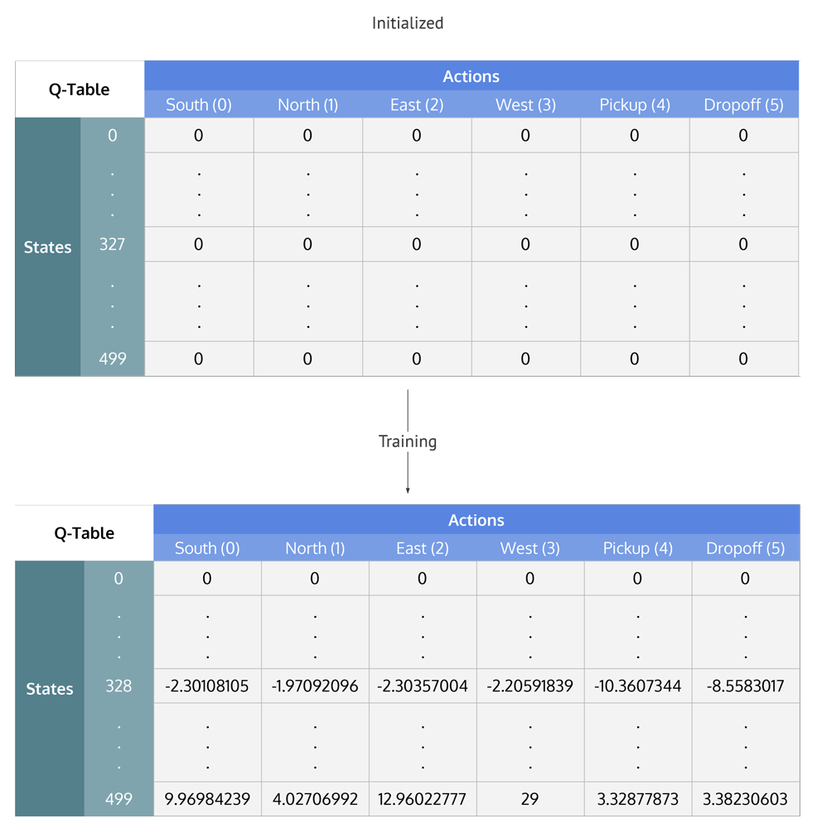

Theoretical Foundation
Q-Table:
The Q-table is a lookup table of shape |S| × |A| (in our case 16 × 4). Each entry Q(s, a) stores the estimated value of taking action a in state s. Initially, all entries are set to zero. As the agent interacts with the environment, these values are updated using the Bellman equation.
ε-Greedy Policy (Exploration vs. Exploitation):
The ε-greedy policy balances exploration and exploitation:
- With probability ε → the agent selects a random action (exploration).
- With probability (1 − ε) → the agent selects the action with the highest Q-value (exploitation).
Early in training, ε is set high (e.g., 0.2) to encourage exploration. As training progresses, ε can be decayed to favour exploitation of learned knowledge.
Off-Policy Learning:
Q-Learning is an off-policy algorithm -> Q-value uses the max Q-value of the next state (greedy action), i.e. Q-value of 14th state will use the max Q-value of state 15th, regardless of which action was actually taken in 14th state. This allows the agent to learn the optimal policy even while following an exploratory (ε-greedy) policy.
[On-policy methods learn from the actions generated by the current version of the policy it is trying to improve. The behavior policy (used to act) and the target policy (used to learn) are the same.]
[Off-policy methods can learn about a target policy from data generated by a different behavior policy, often an older or more exploratory one]
Convergence Guarantee:
Q-Learning is guaranteed to converge to the optimal Q-values Q*(s, a) under two conditions:
- Every state-action pair is visited infinitely often (sufficient exploration).
- The learning rate α decays over time.
How the Q-Learning Algorithm Works — Step by Step:
- Initialize Q-table: All set Q(s, a) = 0.
- Start episode: Place the agent at a random starting state.
- Choose action: Using ε-greedy policy, then select an action.
- Execute action: Move to next state s' and receive reward R.
- Update Q-value: Apply the Bellman update equation.
- Transition: Set s ← s' (move to next state).
- Repeat: Continue until the agent reaches the goal (terminal state).
- New episode: Repeat the entire process for many episodes (e.g., 1000).
Advantages of Q-Learning:
- Trial and Error Learning: Improves over time by trying different actions and learning from experience.
- Self-Improvement: Mistakes lead to learning, helping the agent avoid repeating them.
- Better Decision-Making: Stores successful actions to avoid bad choices in future situations.
- Autonomous Learning: Learns without external supervision, purely through exploration.
- Guaranteed Convergence: Converges to optimal policy under appropriate conditions.
Limitations of Q-Learning:
- Slow Learning: Requires many episodes, making it time-consuming for complex problems.
- Curse of Dimensionality: Large state and action spaces make the Q-table too large to handle efficiently.
- Limited to Discrete Actions: Struggles with continuous action spaces.
- Expensive in Some Environments: In robotics, testing actions can be physically costly.
These limitations motivate Deep Q-Learning (DQN), which replaces the Q-table with a neural network.

3. Learning Outcomes
After completing this lab, you will be able to:
- Define and explain the Q-Learning algorithm and its relationship to the Bellman equation.
- Mathematically formulate a reinforcement learning problem as an MDP.
- Implement a Q-table and update it using the TD update rule.
- Implement and analyze the ε-greedy exploration strategy.
- Understand the concepts of off-policy learning, TD error, and convergence.
- Visualize learned Q-values as heatmaps to interpret agent behavior.
- Compare Q-Learning performance across different hyperparameter settings.
- Identify when Q-Learning fails and why Deep Q-Networks are needed.

4. Implementation Roadmap
The implementation follows the notebook Q_Learning.ipynb, which solves the 4×4 grid world problem. A second notebook demonstrates Q-Learning on the OpenAI Gym FrozenLake environment.
Notebook 1: Q_Learning.ipynb (4×4 Grid World)
Step 1: Import Libraries — numpy for computation, matplotlib for visualization.
Step 2: Define Environment Parameters — 16 states (4×4 grid), 4 actions, goal at state 15.
Step 3: Initialize Q-Table — Create a 16×4 zero matrix to store Q-values.
Step 4: Set Hyperparameters — learning_rate=0.8, discount_factor=0.95, exploration_prob=0.2, epochs=1000.

Step 5: Define State Transition Function — get_next_state(state, action) computes new position based on grid boundaries.
Step 6: Training Loop — For each epoch: start at random state, choose action via ε-greedy, execute, update Q-value, repeat until goal reached.

Step 7: Visualize Results — Generate a heatmap of learned Q-values across the 4×4 grid using matplotlib.
Notebook 2: Q_Learning.ipynb (FrozenLake with OpenAI Gym)
Step 1: Import Libraries — gym, pandas, random, numpy.

Step 2: Create Environment — gym.make('FrozenLake') creates the standard FrozenLake-v1 environment.

Step 3: Initialize Q-Dictionary — Q[(s,a)] = 0.0 for all state-action pairs.

Step 4: Define ε-Greedy Policy — Function that returns random action with probability ε, else best action.

Step 5: Set Hyperparameters — α=0.85, γ=0.90, ε=0.8, 5000 episodes, 1000 steps per episode.

Step 6: Training Loop — Apply Q-Learning update rule: Q(s,a) = Q(s,a) + α(r + γ max Q(s',a') − Q(s,a)).

Step 7: Extract Optimal Policy — After training, select action with maximum Q-value for each state.

5. How to Open and Execute the Notebook
- Open the provided notebook (Q_Learning_in_Reinforcement_Learning.ipynb or Q_Learning.ipynb) in Google Colab or Jupyter Notebook.
- Install required libraries if needed: pip install numpy matplotlib gym pandas.
- Execute cells sequentially using Shift + Enter.
- Observe the Q-table updates and heatmap visualization after training completes.
- Modify hyperparameters (learning rate, discount factor, epsilon, number of epochs) and re-run to observe changes.
- Compare results between different parameter settings to understand their effect on learning.

6. Suggested Activities for Students Post Completion of This Lab Sheet
To reinforce understanding, students should attempt the following experiments:

Experiment 1: Vary the Exploration Rate (ε)
Objective: Understand the impact of exploration vs. exploitation.
- Run the notebook with ε = 0.01, 0.1, 0.2, 0.5, 0.9.
- For each value, record: number of episodes to converge, average reward, path quality.
- Plot a comparison graph of cumulative rewards across different ε values.
- Key question: What happens when ε is too low (insufficient exploration) or too high (excessive randomness)?

Experiment 2: Vary the Learning Rate (α)
Objective: Understand how fast the agent should incorporate new information.
- Test α = 0.1, 0.3, 0.5, 0.8, 1.0.
- Observe convergence speed and stability of Q-values.
- Key question: What happens when α = 1.0 (no memory of past estimates)?

Experiment 3: Vary the Discount Factor (γ)
Objective: Understand the trade-off between short-term and long-term rewards.
- Test γ = 0.1, 0.5, 0.9, 0.99, 1.0.
- Compare learned paths and Q-value distributions.
- Key question: How does γ affect the agent's preference for shorter vs. longer paths?

Experiment 4: Add More Obstacles
Objective: Test Q-Learning in a more complex environment.
- Modify the environment to add 2-4 obstacle cells with reward = −10.
- Observe whether the agent learns to navigate around obstacles.
- Increase grid size to 6×6 or 8×8 and compare training time.

Experiment 5: Implement Epsilon Decay
Objective: Gradually shift from exploration to exploitation.
- Start with ε = 1.0 and decay by a factor (e.g., 0.995) after each episode.
- Set a minimum ε floor (e.g., 0.01).
- Compare this decaying ε strategy with fixed ε.

Experiment 6: Try the FrozenLake Environment
Objective: Apply Q-Learning to a stochastic (slippery) environment.
- Use the Q_Learning.ipynb notebook with OpenAI Gym FrozenLake.
- Compare performance on slippery (is_slippery=True) vs. non-slippery versions.
- Key question: How does stochasticity in transitions affect learning?

Experiment 7: Compare Q-Learning with Random Policy
Objective: Demonstrate the value of learned policies.
- Run a random agent (selects actions uniformly at random) for the same number of episodes.
- Compare total rewards, success rate, and average path length.
- Create a bar chart comparing metrics between Q-Learning and random policy.

7. Useful Links and Datasets for Q-Learning

OpenAI Gym / Gymnasium Environments
- FrozenLake-v1: https://gymnasium.farama.org/environments/toy_text/frozen_lake/
- Taxi-v3: https://gymnasium.farama.org/environments/toy_text/taxi/
- CliffWalking-v0: https://gymnasium.farama.org/environments/toy_text/cliff_walking/
- Blackjack-v1: https://gymnasium.farama.org/environments/toy_text/blackjack/

Custom Grid World Resources
- Simple Grid World Implementation: https://github.com/udacity/deep-reinforcement-learning
- Grid World Visualization: https://cs.stanford.edu/people/karpathy/reinforcejs/gridworld_td.html

Tutorials and Documentation
- Sutton & Barto Textbook (Chapter 6 — TD Learning): http://incompleteideas.net/book/the-book.html
- Gymnasium Official Documentation: https://gymnasium.farama.org/
- Q-Learning Tutorial (Towards Data Science): https://towardsdatascience.com/q-learning-algorithm-from-explanation-to-implementation-cdbeda2ea187
- David Silver RL Course (UCL, Lecture 5): https://www.davidsilver.uk/teaching/
- DeepMind x UCL RL Lecture Series: https://www.deepmind.com/learning-resources/introduction-to-reinforcement-learning-with-david-silver

Datasets for Further Exploration
- OpenAI Gym Leaderboards: https://github.com/openai/gym/wiki/Leaderboard
- RL Benchmark Environments (Gymnasium): https://gymnasium.farama.org/environments/
- D4RL Offline RL Datasets: https://github.com/Farama-Foundation/D4RL
- Minigrid (Grid World Research Environments): https://github.com/Farama-Foundation/Minigrid

8. Summary
This lab introduces Q-Learning as a foundational model-free reinforcement learning algorithm. Through the robot navigation grid world problem, students learn how an agent can discover optimal behavior purely through trial-and-error interaction with the environment.
Key takeaways:
- Q-Learning uses a Q-table to store estimated values for every state-action pair.
- The Bellman update equation incrementally improves Q-value estimates using temporal difference learning.
- The ε-greedy policy provides a principled way to balance exploration and exploitation.
- Q-Learning is off-policy: it learns the optimal policy regardless of the behavior policy used during training.
- Convergence is guaranteed when all state-action pairs are visited sufficiently and the learning rate decays.
- Q-values can be visualized as heatmaps to interpret what the agent has learned.
Connection to broader RL concepts:
- Q-Learning builds on the Bellman equation from Dynamic Programming.
- It extends the concepts of value estimation introduced with Multi-Armed Bandits.
- It serves as the direct precursor to Deep Q-Networks (DQN), which replace the Q-table with a neural network.
Progression of the course:
- Multi-Armed Bandits → introduced exploration-exploitation trade-off.
- Q-Learning → introduced temporal difference learning, Q-tables, and MDP formulation.
- Deep Q-Networks (DQN) → next topic, extends Q-Learning to high-dimensional state spaces using neural networks.
Code Implementation Notebooks:
- Q_Learning.ipynb — 4×4 Grid World with custom environment Q_Learning.ipynb
- Q_Learning.ipynb — FrozenLake with OpenAI Gym (backup/reference) : Q_Learning(backUp).ipynb

